**HOME PAGE**



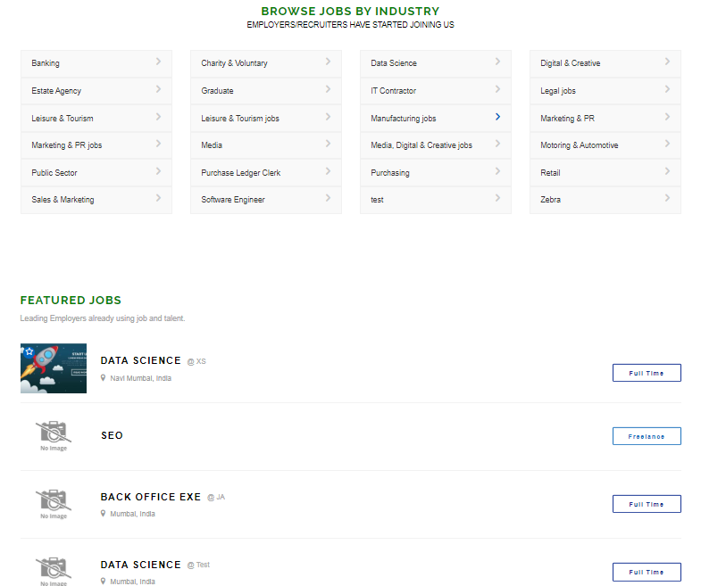







**-------------------------------------------------------------------------------------------------**

**ABOUT JOBAAPKA**

After successful working of ideators, a technology development as well as digital marketing and big data training company based out of Thane,this is our new initiative and venture, Jobaapka.com

Our objective is not just to make the candidates/jobseekers find the suitable and the right job but make them skilled,efficient and productive in their job hunt through our optional services.

We aim to make the employers grow not only in terms of hiring right people but also empowering them with the most effective and highly workable technology which will address their business issues.

This portal provides the most unique service in terms of Hiring/Recruitment and Technology Consulting for the Employers as well as Interview preparation,CV writing and Job assistance service for the Jobseekers.

Below points explain you how -

**A SINGLE PLAN SOLUTION –**

Hassle free and only one simple plan for your Hiring as well as Technology needs at a very low price which you would have never got or thought before.

**A WIN WIN SCENARIO FOR BOTH EMPLOYERS AND JOBSEEKERS -**  
Our working style and systematic process makes this a favourable situation for both the parties as we give you ample time to resolve your issues.Know more about that in [**Our plan**](https://jobaapka.com/our-plan/)

**TECHNOLOGY CONSULTING AS PER YOUR BUSINESS PROBLEMS -**  
We understand your business not only in terms of your manpower requirement but also in form of a highly affordable technology that you can decide through our free technology consulting session.

**PERSONAL JOB ASSISTANCE FOR JOBSEEKERS -**  
We help candidates who have subscribed for [**our plan**](https://jobaapka.com/our-plan/) with CV writing,Interview preparation as well as second job or 6 months of support ,whatever comes first after losing out on their previous job.

**100% CREDIBLE AND TRUSTWORTHY -**  
With all our credentials and reputation we have gained,you can easily rely on us and be certainly assured of 100% quality and perfect services from us.

OUR CLIENTS ACROSS DIFFERENT INDUSTRIES



Using our job hiring/recruitment services



Using our technology/app development services

Know more below about why and what we can deliver for you

[**Why us**](https://jobaapka.com/why-us/)[**Jobseekers learn here what we have in store for you**](https://jobaapka.com/jobseeker/)[**Employers know here what we have to offer you**](https://jobaapka.com/employer/)

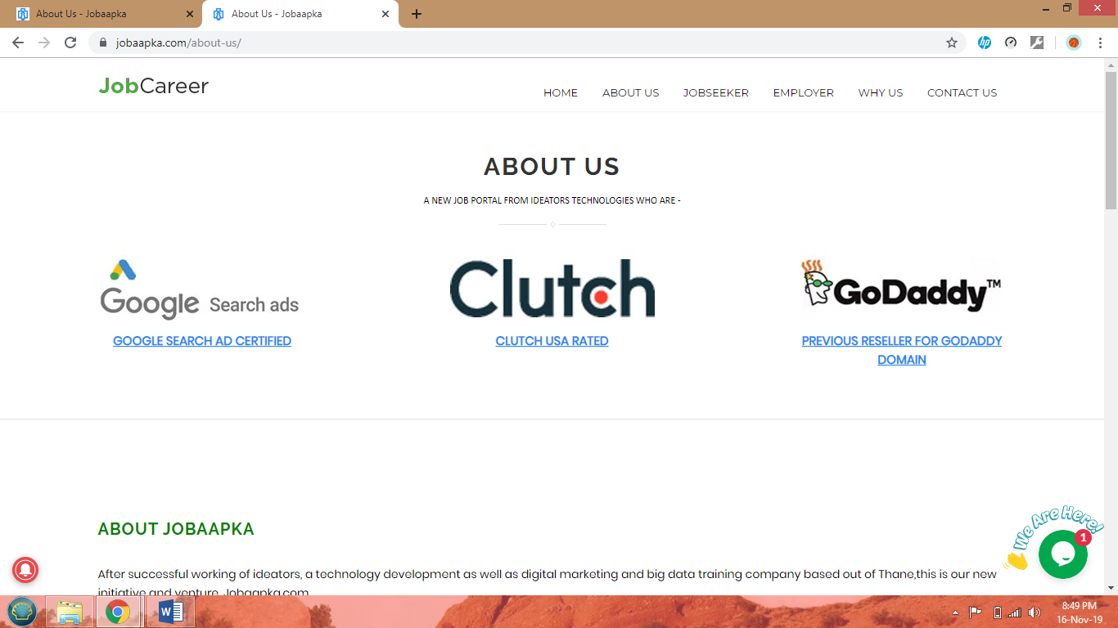

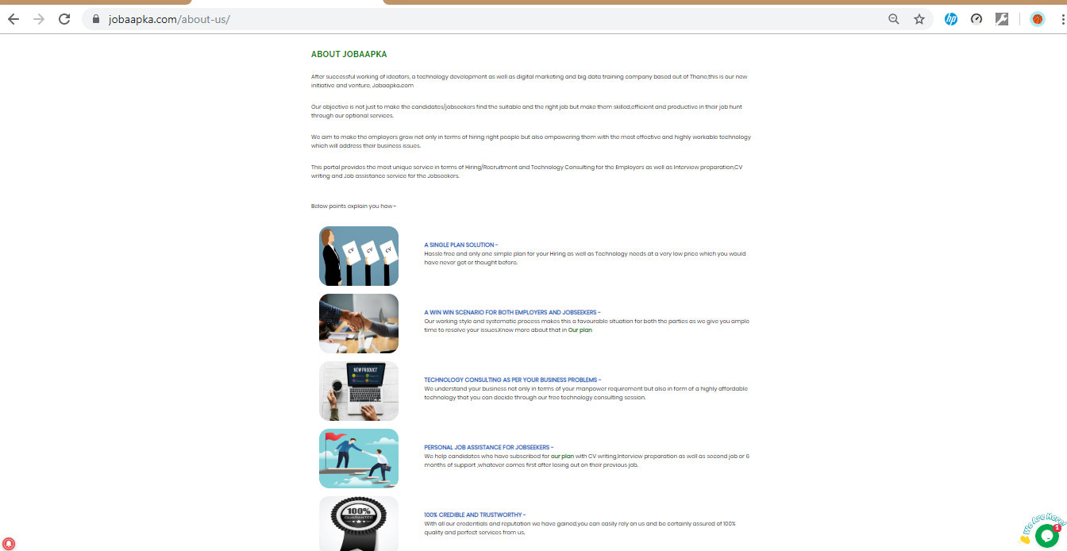

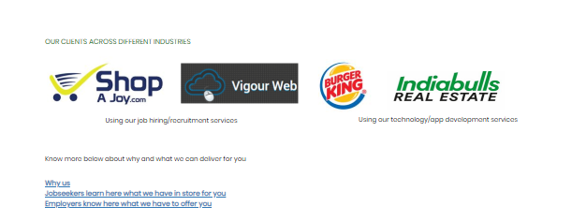

**-------------------------------------------------------------------------------------------------**

**WHY US**

There is no doubt that thousands of other websites provide job services.

Its very logical question to ask that what difference we will make and what really we can do for you which others cannot?

Before starting our new venture Jobaapka.com, this is what Ideators Technologies has achieved that makes us stand out from the big crowd of job websites and give us strong edge over our competitors.

## 1) CLUTCH,USA CERTIFIED - <https://clutch.co/profile/ideators-technologies>

Clutch is an independent platform that collects objective feedback from clients about each company registered on the site. They perform in-depth interviews with clients and customers about the quality of their interaction with each Clutch-registered company. Based on the data gathered, the service formulates a fair rating of all the firms. Clutch categorises companies by their geographic location,a field of their expertise and the focus on proven skills.

[Read more here - https://clutch.co/](https://clutch.co/)

## 2) GOOGLE SEARCH ADS CERTIFIED - <https://academy.exceedlms.com/student/award/33034979>

Every second, there are 2.3 million searches performed on Google, and the majority of search results pages include Google ads.Whenever you look for a product or service online, Google (or any other search-engine provider) displays a results page consisting of both organic and sponsored results.

[Read more here - https://support.google.com/google-ads/answer/9029201](https://support.google.com/google-ads/answer/9029201)

## 3) PREVIOUS DOMAIN RESELLER FOR GODADDY - <https://in.godaddy.com/reseller-program/hosting>

## 4) OUR SERVICES -

We provide you all the requisite services at the most lowest cost for both Employers and Jobseekers. Learn more about that in [**Our plan**](https://jobaapka.com/our-plan/)

OUR CLIENTS ACROSS DIFFERENT INDUSTRIES







[**Know more about Job Aapka**](https://jobaapka.com/about-us/)

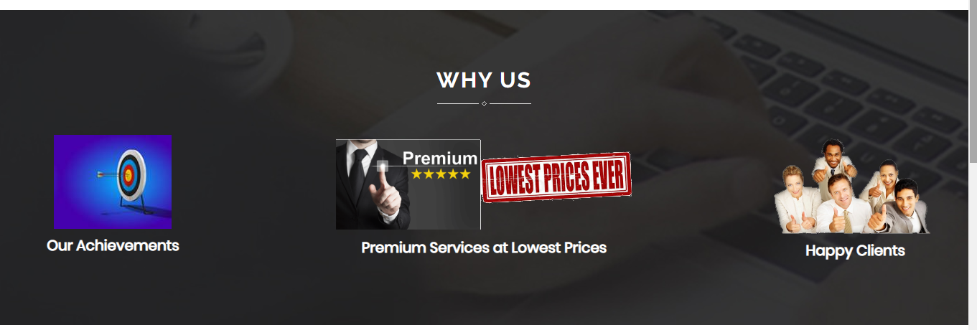

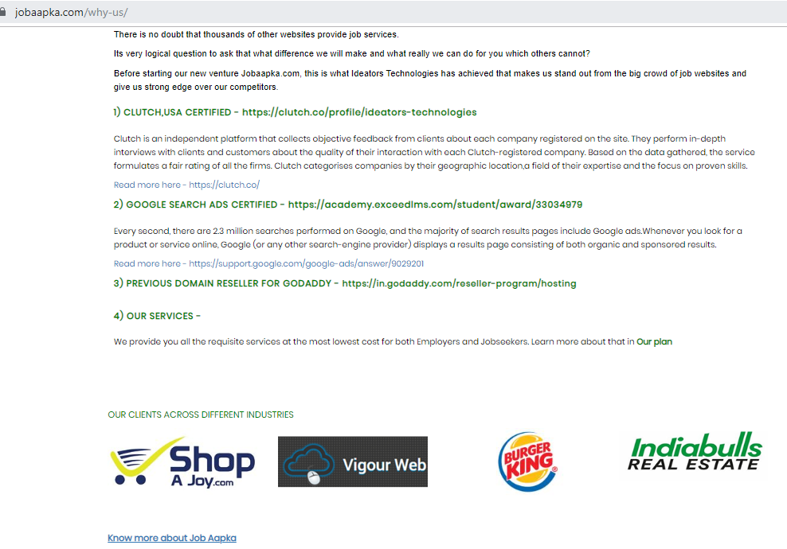

**-------------------------------------------------------------------------------------------------**





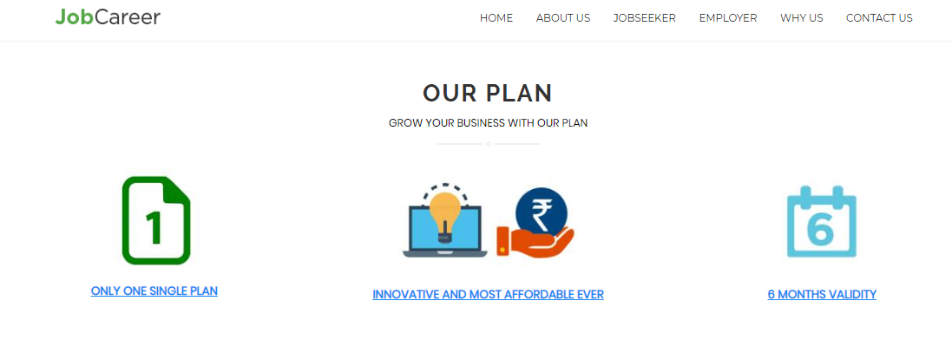**-------------------------------------------------------------------------------------------------**

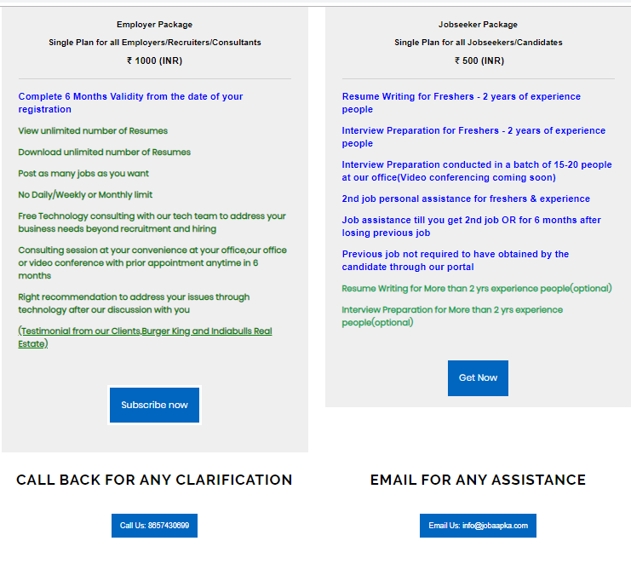

* **Employer Package**

**Single Plan for all Employers/Recruiters/Consultants**

**₹ 1000 (INR)**

* + **Complete 6 Months Validity from the date of your registration**
  + **View unlimited number of Resumes**
  + **Download unlimited number of Resumes**
  + **Post as many jobs as you want**
  + **No Daily/Weekly or Monthly limit**
  + **Free Technology consulting with our tech team to address your business needs beyond recruitment and hiring**
  + **Consulting session at your convenience at your office,our office or video conference with prior appointment anytime in 6 months**
  + **Right recommendation to address your issues through technology after our discussion with you**
  + [**(Testimonial from our Clients,Burger King and Indiabulls Real Estate)**](https://clutch.co/profile/ideators-technologies)

**Jobseeker Package**

**Single Plan for all Jobseekers/Candidates**

**₹ 500 (INR)**

* **Resume Writing for Freshers - 2 years of experience people**
* **Interview Preparation for Freshers - 2 years of experience people**
* **Interview Preparation conducted in a batch of 15-20 people at our office(Video conferencing coming soon)**
* **2nd job personal assistance for freshers & experience**
* **Job assistance till you get 2nd job OR for 6 months after losing previous job**
* **Previous job not required to have obtained by the candidate through our portal**
* **Resume Writing for More than 2 yrs experience people(optional)**
* **Interview Preparation for More than 2 yrs experience people(optional)**

**------------------------------------------------------------------------------------------------**





